**Practical 7**

**Aim:** How your site performs, reveal why it's slow and discover optimization opportunities with GTMetrix.

**Software Required:** GTMetrix.

**Theory/Logic:**

here I selected two website first is Charusat and second one is Youtube

Below is GTmetrix report of Charusat Website.

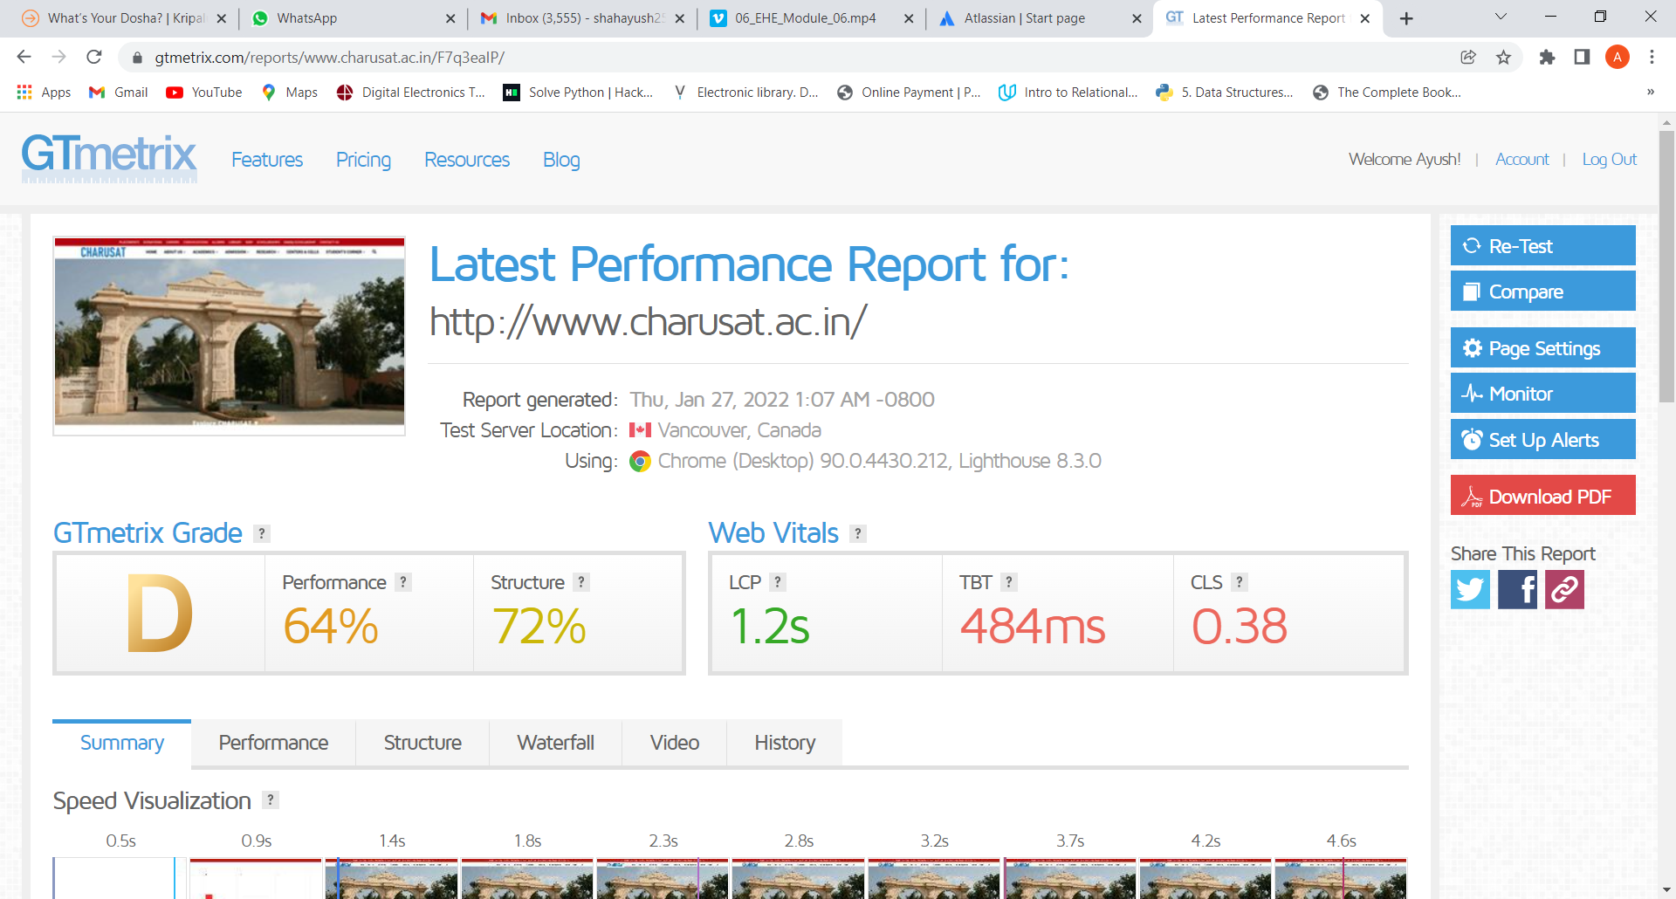

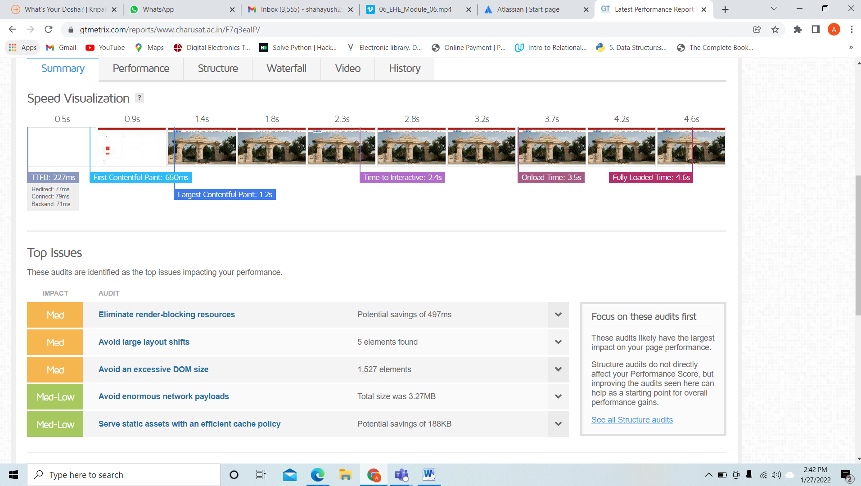

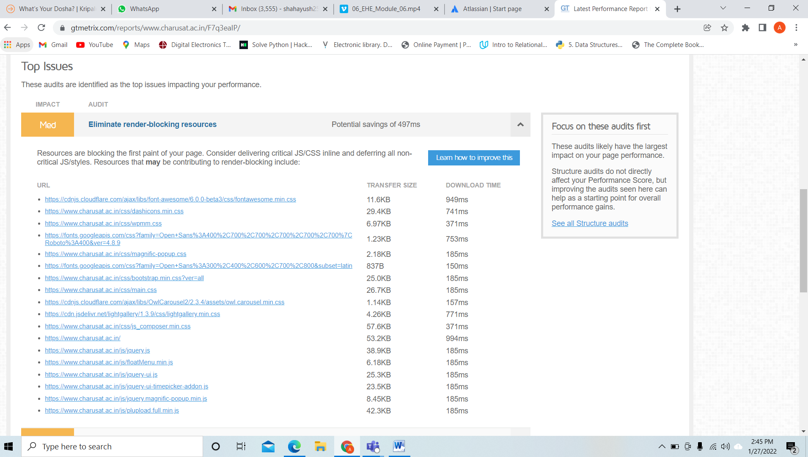

This issue about large layout shift means if we have to do payment for an item in ecommerce then some time an element gets rendered above the container so we unfortunately not able to click on right place.

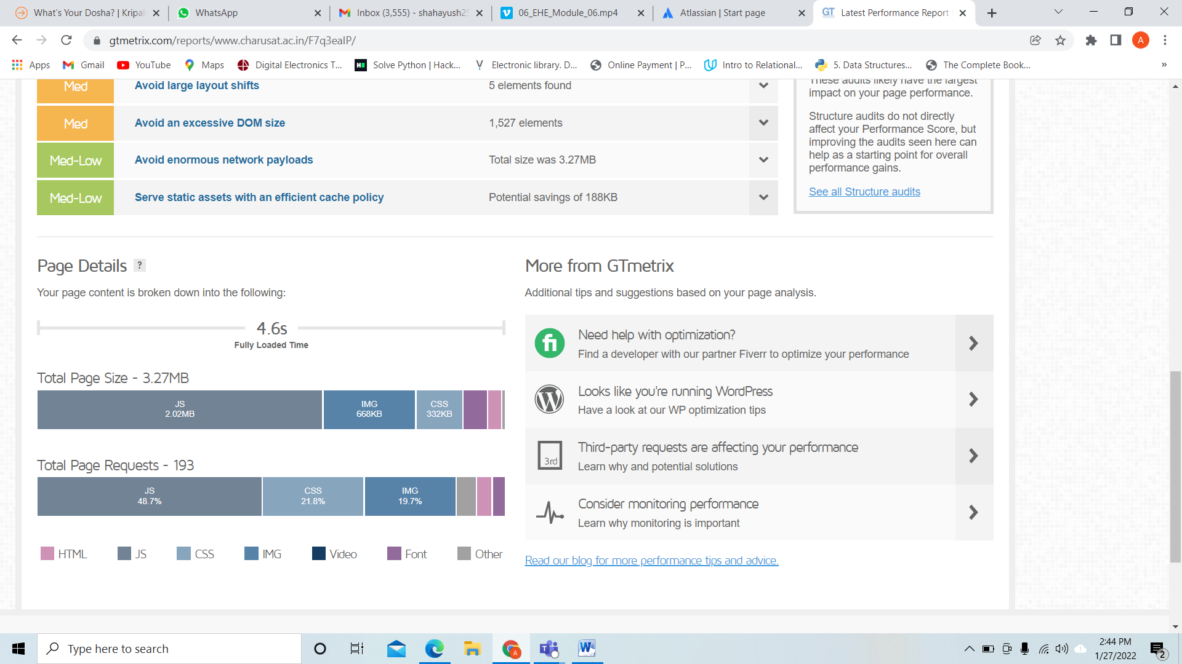

**Below images are the comparison between Charusat and Youtube.**

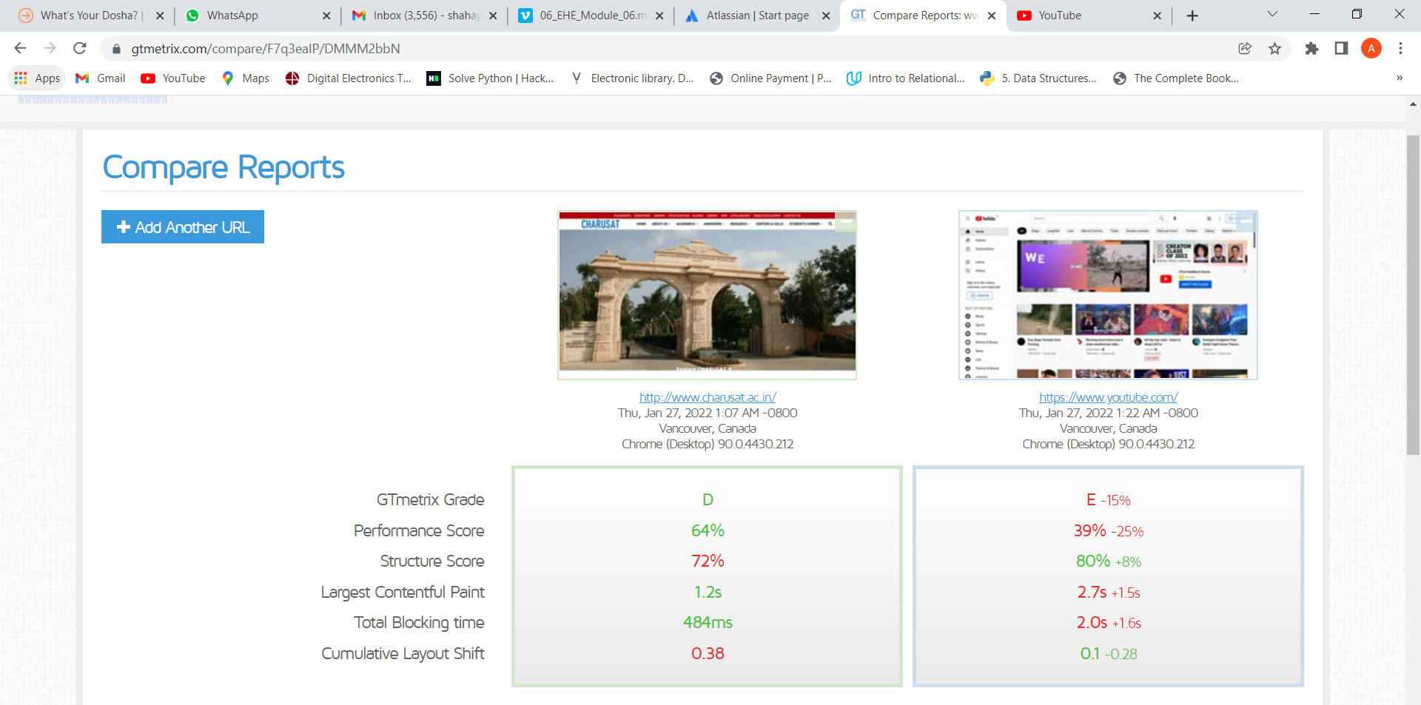

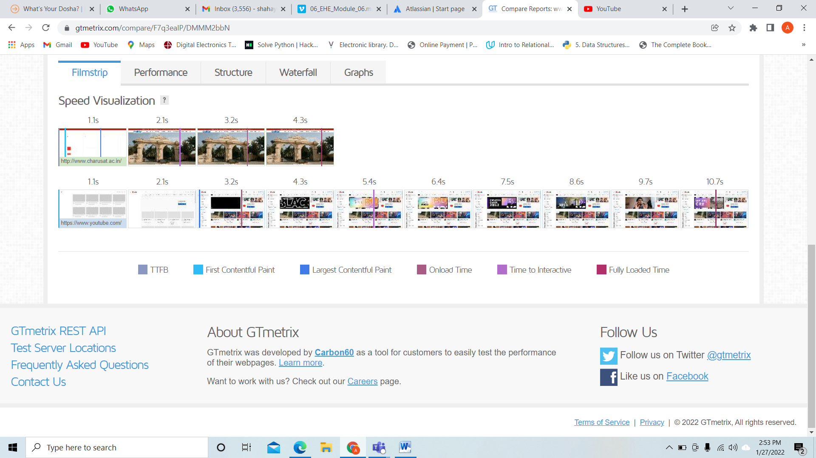

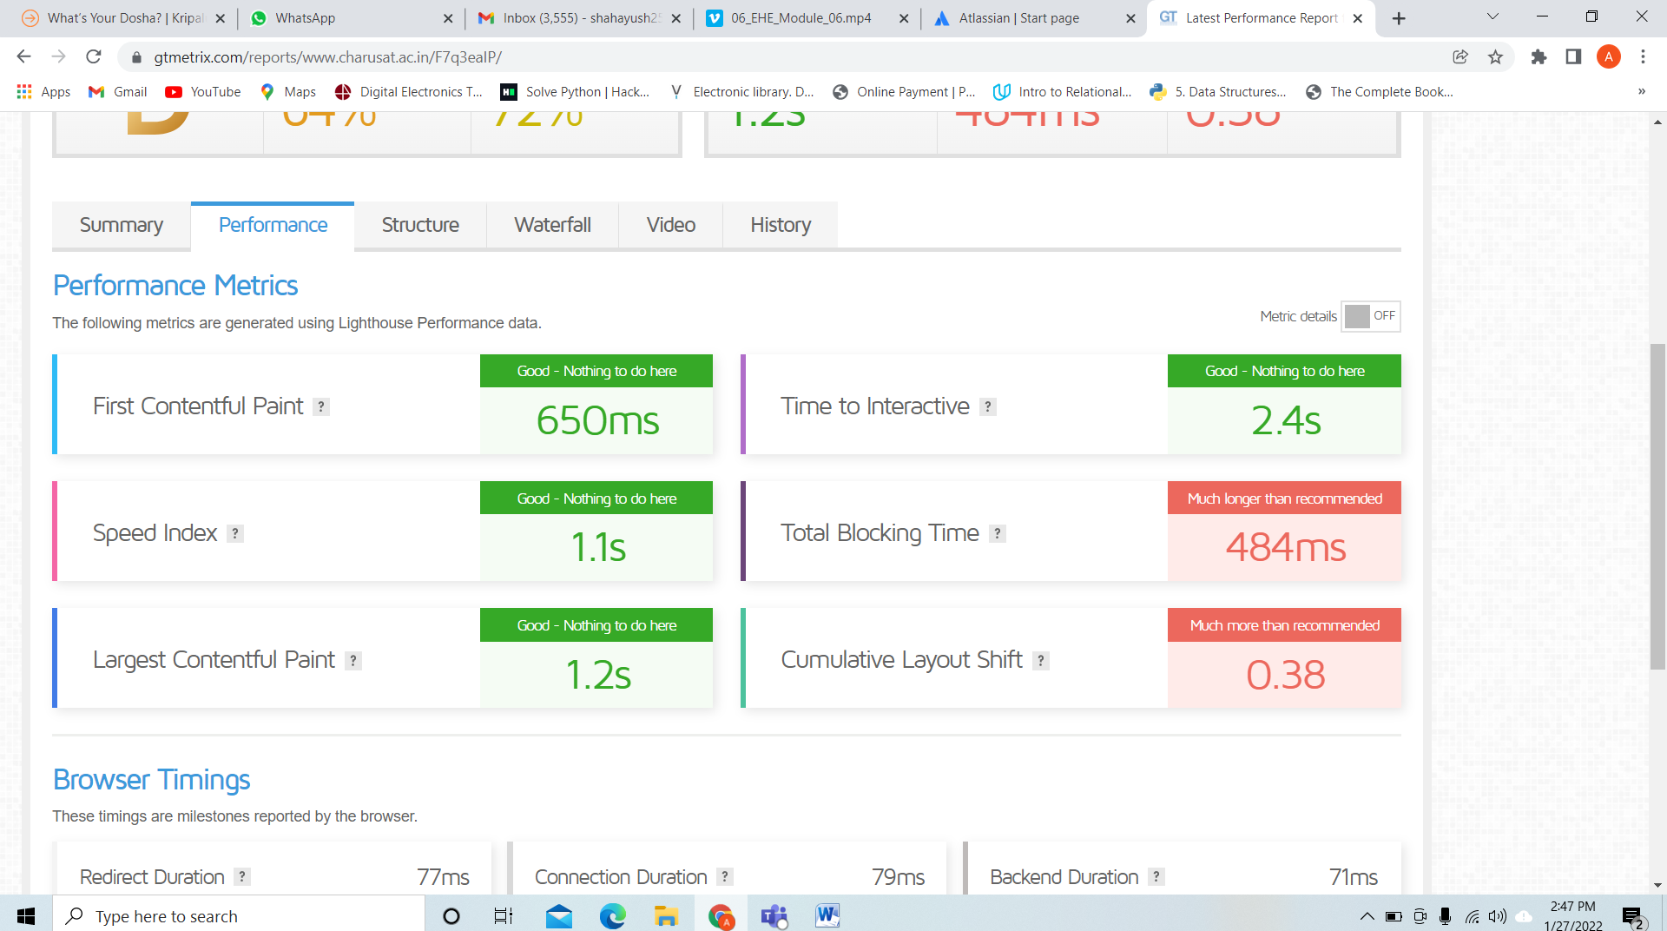

**Application:**

GTMetrix is a tool that analyzes the page speed and performance. It generates scores for our pages and offers Pagespeed and WiSlow. It is a free tool that we have found to be used to get detailed reports about site performance. It creates scores for the pages and also provides recommendations to fix them. It allows us to run accurate analytics from the WordPress dashboard.

**Conclusion:**

In this practical I explore GTmetrix Tool, I learned how to check the performance of any website, also compare the different sites and knows based on which parameter GTmetrix give us the performance report and also learned how to fix issues that affect the site performance.

**Reference Link:**

[**https://gtmetrix.com/**](https://gtmetrix.com/)